Quantum Computing

A quantum computer can be in a quantum combination of all of those states, called superposition. This allows it to perform one billion or more copies of a computation at the same time.

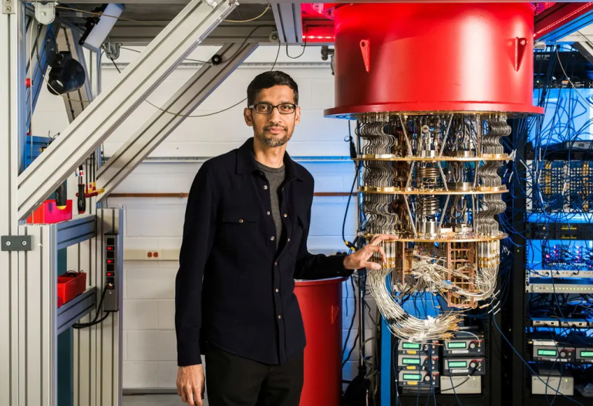

Quantum computing is a type of computing that uses the principles of quantum mechanics to perform operations on data. In traditional computing, data is represented and processed using bits, which can have one of two values: 0 or 1. In quantum computing, data is represented using quantum bits, or qubits, which can exist in multiple states at the same time.

This property is known as superposition, and it allows quantum computers to perform certain types of calculations much faster than traditional computers. Another key property of quantum mechanics is entanglement, which allows qubits to be connected in a way that allows the state of one qubit to be affected by the state of another, even if they are separated by large distances.

These properties make quantum computers highly suited to certain types of problems, such as simulating quantum systems, solving optimization problems and breaking encryption codes that would be impractical or impossible to solve on traditional computers.

However, due to the complexity of quantum mechanics, it is still an active area of research and the full potential of quantum computing is yet to be fully realized.

Is quantum computing the future?

Quantum computing is a relatively new and upcoming technology that uses the principles of quantum physics to solve complex problems. Whilst it is still in the early stages of development, the possibilities and results so far indicate that quantum computing has a promising future in real-world applications.

What can quantum computers do?

A quantum computer can be in a quantum combination of all of those states, called superposition. This allows it to perform one billion or more copies of a computation at the same time.

What can quantum computers do more efficiently than regular computers?

Because quantum computers can perform multiple calculations at once, they may simultaneously follow all of the alternative paths.

* A quantum computer operates under a different set of rules than a classical computer, which is a significant distinction. It can work with something called qubits instead of employing zeros and ones like traditional computers do—bits and bytes.
* A conventional computer, however, can only be in one of these one billion states at once. A quantum computer can exist in **superposition**, which is a quantum combination of all those states. As a result, it can run one billion or more copies of a computation concurrently.
* The ability to prepare quantum bits in a superposition of an exponential number of states is the main justification for a quantum computer's superiority to a classical computer. The quantum algorithm then computes all potential inputs simultaneously.

Thus, compared to conventional computers, quantum computers process information in a fundamentally different way.